**Recommendations for Big Mountain Resort**

**Summary**

Big Mountain Resort has recently installed an additional chair lift to help increase the distribution of visitors across the mountain. This additional chair increases their operating costs by $1,540,000 this season. Through analysis of data from resorts across the country, price changes and potential additions to the resort that will be beneficial for the business have been identified.

**New Chair Lift**

First and foremost, the $1,540,000 cost of the new chair lift could be offset in a single season by a small increase of $0.88 per ticket assuming that the estimated number of tickets sold, which was given by Big Mountain Resort, is accurate. After reviewing the contents of this document, you will find that a price increase of $0.88 per ticket is not only reasonable, but completely justifiable.

**Resort Features**

Big Mountain Resort is a high-quality resort. It ranks highly in the most important features when compared with other resorts across the country, but is closer to the middle of the pack when it comes to ticket prices, as shown in the figures below.

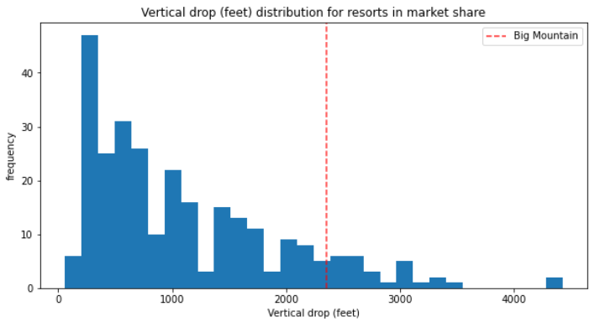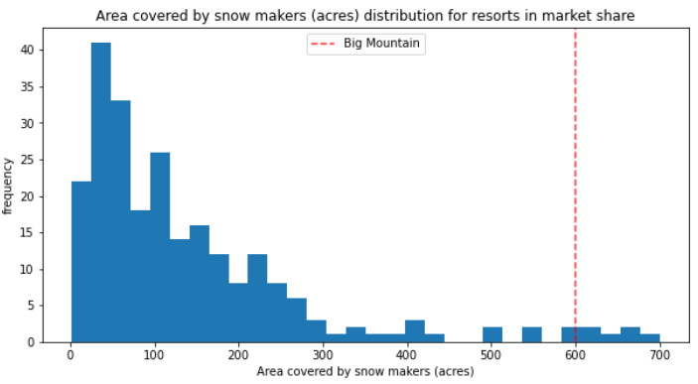

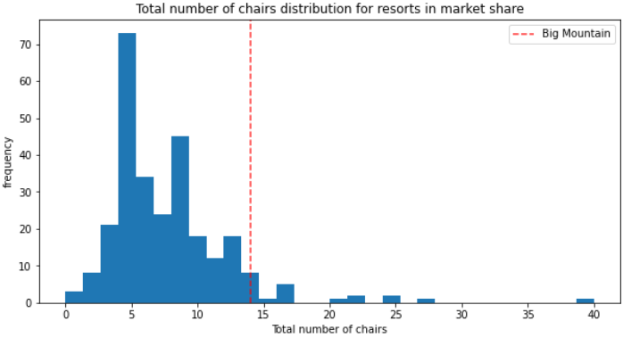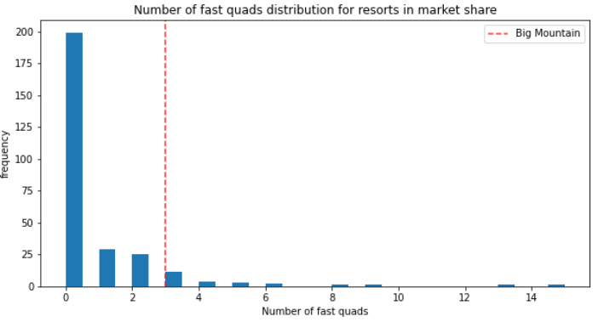

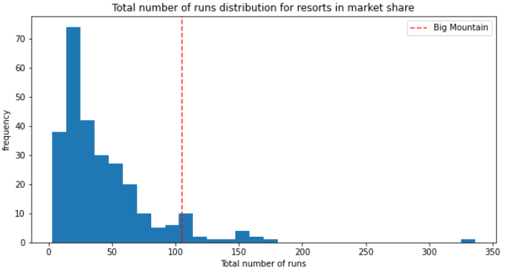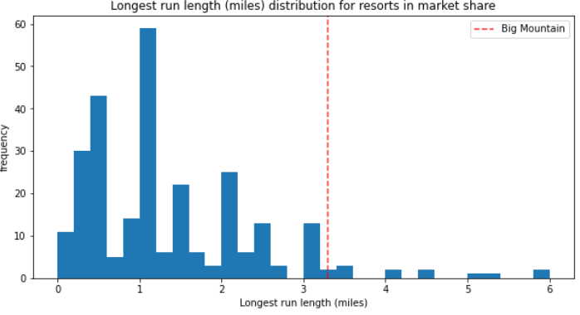

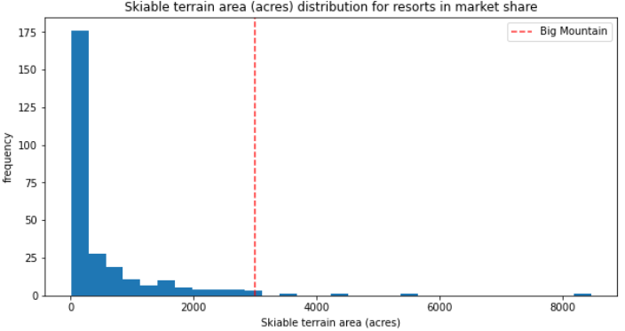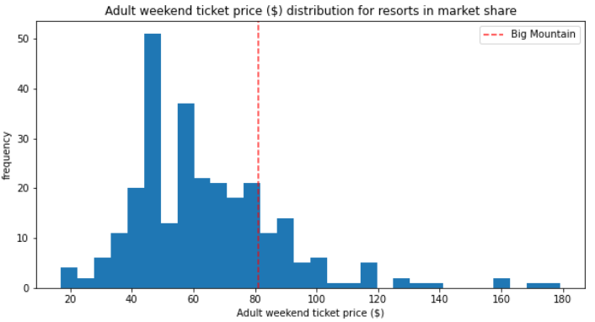

**State Ticket Price**

However, Big Mountain Resort has the highest ticket price in the state of Montana, as shown in the figure below.

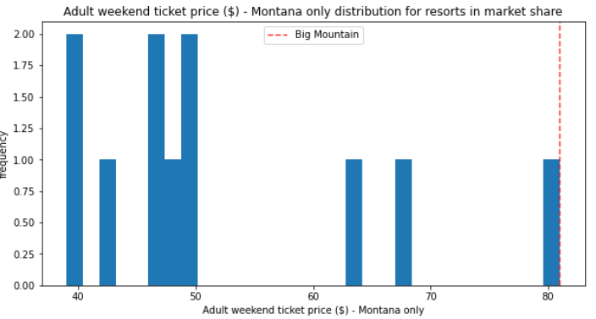

There is already a considerable gap (> $10) between Big Mountain Resort and the next cheapest Montana resort. Thus, it seems that customers of Big Mountain Resort are willing to pay more to go to a quality resort than to go to some of the cheaper and lower quality alternatives nearby.

**Recommended Ticket Price**

Based on the features that Big Mountain Resort has to offer, a ticket price increase to $95.87 can be justified. This increase in price would not only pay for the additional chair lift, but also increase the profits that the resort can earn each season by $26,022,500.

**Future Improvements**

In addition to determining a justifiable ticket price based on resorts across the country, analysis was done to determine the most effective way to increase the value of Big Mountain Resort and future profits. By adding one run, increasing the vertical drop by 150 feet, and installing one additional chair lift, Big Mountain Resort can increase ticket value by $1.99. This is a small increase for the individual customer, but for Big Mountain Resort this could be expected to result in an additional $3,474,638 each season.